Experiment 7: Design of Moving Average Filter using Verilog
Objectives
    - To create and simulate a 4-point Moving Average Filter with RTL Verilog to smooth noisy input data by averaging recent samples.
    - To realize a 4-stage 8-bit shift register (`shift_reg[0:3]`) to continuously store the 4 most recent input samples.
    - To compute the 10-bit cumulative sum (`sum`) of the 4 samples and perform fast division by 4 with bit-wise right-shift logic (`sum >> 2`).
    - To validate filter performance with a Verilog testbench (`tb_moving_average_with_noise`) driving a noisy sinusoidal input wave in Vivado Simulator (XSIM).

Software Required
Xilinx Vivado Design Suite, Vivado Simulator (XSIM), PC or Laptop.
Experimental Procedure
Step 1: Create Vivado Project & RTL Module:
Step 2: Implement Shift Register & Accumulator Logic
Step 3: Develop Testbench with Noisy Sine Input
Step 4: Behavioral Simulation & Waveform Verification

Program
1. RTL Code: Moving Average Filter
module moving_average_filter (
input wire clk,
input wire rst,
input wire [7:0] data_in,
output reg [7:0] data_out
);
reg [7:0] shift_reg [0:3]; // Store last 4 samples
reg [9:0] sum; // Sum of 4 samples (max = 1020)
integer i;
always @(posedge clk or posedge rst) begin
if (rst) begin
for (i = 0; i < 4; i = i + 1)
shift_reg[i] <= 0;
data_out <= 0;
sum <= 0;
end else begin
// Shift samples
shift_reg[3] <= shift_reg[2];
shift_reg[2] <= shift_reg[1];
shift_reg[1] <= shift_reg[0];
shift_reg[0] <= data_in;
// Accumulate and divide by 4 (right shift by 2)
sum <= shift_reg[0] + shift_reg[1] + shift_reg[2] + shift_reg[3];
data_out <= sum >> 2;
end
end
endmodule
  - Testbench Code: Noisy Sine Input Simulation
`timescale 1ns / 1ps
module tb_moving_average_with_noise;
reg clk;
reg rst;
reg [7:0] data_in;
wire [7:0] data_out;
real sine_val;
integer noise;
integer temp;
integer i;
// Instantiate Device Under Test (DUT)
moving_average_filter dut (
.clk(clk),
.rst(rst),
.data_in(data_in),
.data_out(data_out)
);
// 100 MHz System Clock Generation
always #5 clk = ~clk;
initial begin
clk = 0;
rst = 1;
data_in = 0;
#20 rst = 0;
// Drive 100 noisy sine wave samples
for (i = 0; i < 100; i = i + 1) begin
sine_val = 127.0 * (1.0 + $sin(2.0 * 3.14159 * i / 20.0));
noise = ($random % 21) - 10; // Noise range: -10 to +10
temp = $rtoi(sine_val) + noise;
if (temp > 255)
data_in = 8'd255;
else if (temp < 0)
data_in = 8'd0;
else
data_in = temp[7:0];
#10;
end
#100;
$stop;
end
endmodule

Formulas
1. Moving Average Difference Equation:
y[n] = (1/4) * sum_{k=0}^{3} x[n-k] = (x[n] + x[n-1] + x[n-2] + x[n-3]) / 4
2. Bit-Shift Division Relationship:
data_out = sum >> 2 => floor(sum / 4)
3. Accumulator Bit-Width Sizing:
Max Sum = 4 * 255 = 1020 => ceil(log2(1020)) = 10 bits (prevents arithmetic overflow)
4. Noisy Input Synthesis Model:
x[n] = clamp( floor(127.0 * (1.0 + sin(2 * pi * n / 20))) + noise[n], 0, 255 ) where noise in [-10, +10]

Output

S.No | Output Parameter | Expected / Theoretical Value | Simulated / Measured Value | Status / Result
1 | Peak Accumulation Sum | 10-bit Integer (Max 1020) | 1020 | 0% Overflow
2 | Output Division Logic | Bit-wise Right Shift (>> 2) | sum >> 2 | Exact Match
3 | High-Frequency Noise Reduction | Attenuated Ripple | Smooth Sinusoidal Curve | Verified
4 | Output Signal Fidelity | Low-pass Filtered Wave | Verified in XSIM Waveform | Pass

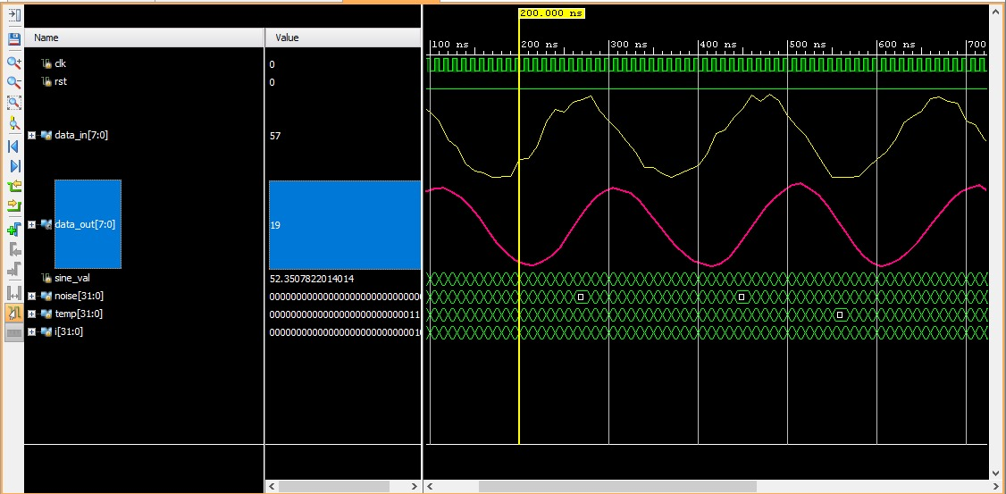
Figure 1: Moving average filtering output

Result
The 4-point Moving Average Filter was successfully designed, implemented, and simulated with RTL Verilog in Xilinx Vivado. A sinusoidal signal corrupted with random additive noise was generated in the testbench and driven into the filter. The simulation waveforms confirmed that the filter effectively suppressed random noise fluctuations while accurately preserving the underlying sinusoidal signal shape. The smoothed output waveform validated the correct operation of the moving average filter as a low-pass FIR filter.

